VEX V5 Override: Session 2 - Building Station

Activity: Build the Override Hero Bot, Flex.

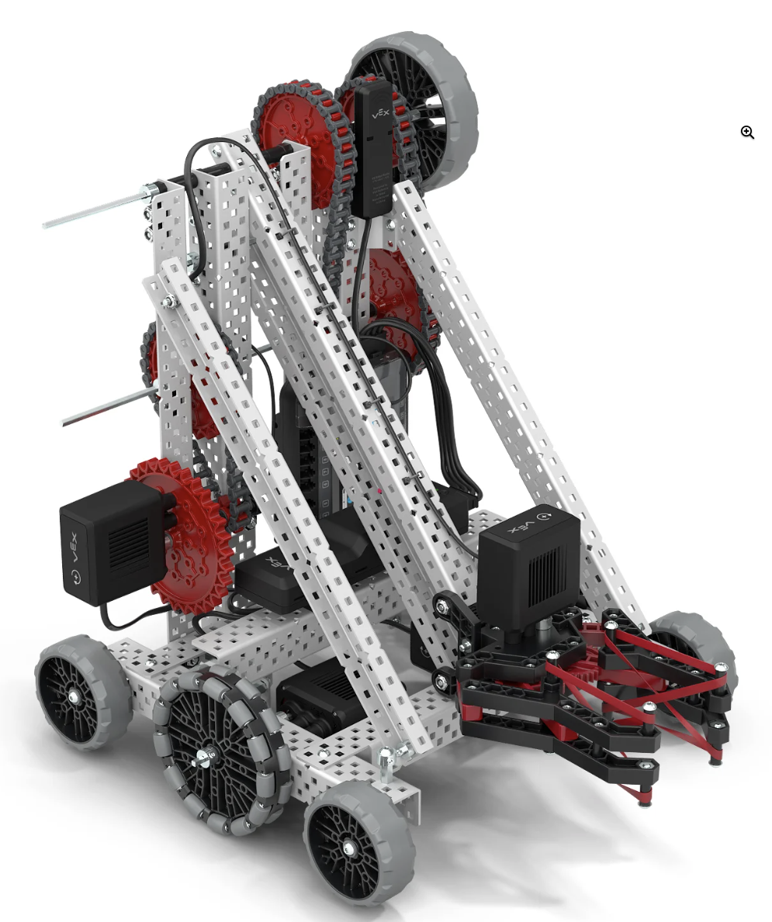
The Hero Bot, Flex, will be built in stages so each person on the team gets a chance to build. Building in pairs is recommended for ease and accuracy of building. Check each and every step as it is completed in the build instructions to ensure Flex is built correctly.
Complete the build instructions based on where the previous team members left off. Adjust these building stages as needed to match the number of members on your team.
Build Instructions for Flex can be found here.
- Stage 1: Steps 1 through 35
- Stage 2: Steps 36 through 68
- Stage 3: Steps 69 through 89
- Stage 4: Steps 90 through 107
  - This stage also includes testing the build by:
    - Attaching the Battery
    - Pairing the Controller and Brain
    - Starting the Built-In Drive Program to test the build
    - Driving Flex on the floor to pick up a Pin or Cup and move it to another location.
  - If any element of the build does not work as expected, go back and check the build instructions, then make repairs as needed.
Feeling Stuck?
- Print out and use the V5 Printable Parts Ruler to help you locate the correct size of pieces in the kit.
- Reference the V5 Competition Starter Kit Poster to help you as you are building.

Discussion Questions While Building  - How do you think the section you are working on in your group relates to the whole build?  - What is one pro-tip you would give to a group building another stage of the robot?  - How do you think Flex collects, carries, and scores Pins? | Activity Checklist  - Each team member built part of the robot.  - Stage 1 steps complete  - Stage 2 steps complete  - Stage 3 steps complete  - Stage 4 steps complete  - Flex drives, grips and lifts a Pin or Cup.

